**De Beers Tracks First Gems From Mine to Shop Using Blockchain**

By

[Thomas Biesheuvel](https://www.bloomberg.com/authors/APYfT9sMCsg/thomas-biesheuvel)

May 10, 2018, 11:09 AM GMT+2

* https://www.bloomberg.com/news/articles/2018-05-10/de-beers-tracks-first-gems-from-mine-to-shop-using-blockchain

Bitcoin technology helps guard against fakes, blood diamonds



Virtual ledger shows transactions while keeping them anonymous

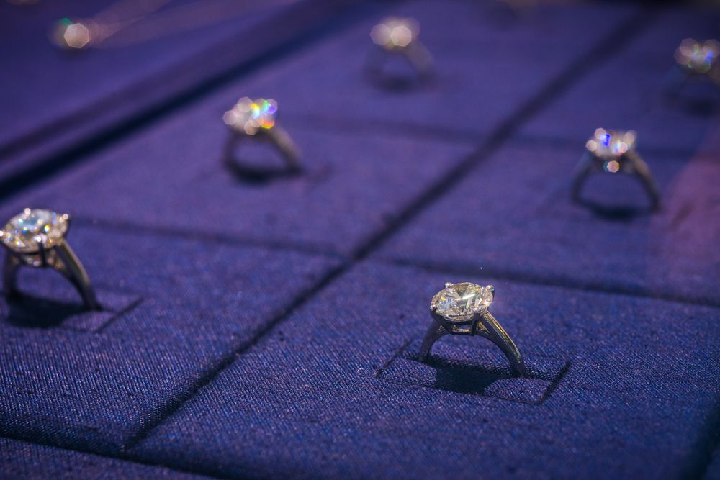

Diamond rings are displayed in a cabinet inside a De Beers SA store in Hong Kong.

 Photographer: Calvin Sit/Bloomberg

LISTEN TO ARTICLE

1:17

SHARE THIS ARTICLE

[Share](https://www.facebook.com/sharer/sharer.php?u=https%3A%2F%2Fwww.bloomberg.com%2Fnews%2Farticles%2F2018-05-10%2Fde-beers-tracks-first-gems-from-mine-to-shop-using-blockchain)

[Tweet](https://twitter.com/share?text=De%20Beers%20tracks%20its%20first%20gems%20all%20the%20way%20from%20a%20mine%20to%20a%20retailer%20using%20blockchain&via=markets&url=https%3A%2F%2Fwww.bloomberg.com%2Fnews%2Farticles%2F2018-05-10%2Fde-beers-tracks-first-gems-from-mine-to-shop-using-blockchain)

[Post](https://www.linkedin.com/shareArticle?mini=true&title=De%20Beers%20Tracks%20First%20Gems%20From%20Mine%20to%20Shop%20Using%20Blockchain&summary=The%20world%E2%80%99s%20biggest%20diamond%20producer%20says%20it%E2%80%99s%20tracked%20its%20first%20diamonds%20all%20the%20way%20from%20the%20mine%20to%20jewelry%20retailers%20using%20the%20technology%20behind%20bitcoin.&url=https%3A%2F%2Fwww.bloomberg.com%2Fnews%2Farticles%2F2018-05-10%2Fde-beers-tracks-first-gems-from-mine-to-shop-using-blockchain)

[Email](mailto:?subject=De%20Beers%20Tracks%20First%20Gems%20From%20Mine%20to%20Shop%20Using%20Blockchain%20-%20Bloomberg&body=De%20Beers%20Tracks%20First%20Gems%20From%20Mine%20to%20Shop%20Using%20Blockchain%0D%0A%0D%0Aby%20Thomas%20Biesheuvel%0D%0A%0D%0AThe%20world%E2%80%99s%20biggest%20diamond%20producer%20says%20it%E2%80%99s%20tracked%20its%20first%20diamonds%20all%20the%20way%20from%20the%20mine%20to%20jewelry%20retailers%20using%20the%20technology%20behind%20bitcoin.%0D%0A%0D%0Ahttps%3A%2F%2Fwww.bloomberg.com%2Fnews%2Farticles%2F2018-05-10%2Fde-beers-tracks-first-gems-from-mine-to-shop-using-blockchain)

The world’s biggest diamond producer says it’s tracked its first diamonds all the way from the mine to jewelry retailers using the technology behind bitcoin.

De Beers, which is [piloting](https://www.bloomberg.com/news/articles/2018-01-16/diamond-trade-turns-to-technology-that-keeps-bitcoin-anonymous) a scheme using blockchain to create a virtual ledger of diamond sales, said that 100 high-value stones were tracked through the cutting, polishing and manufacturing process to a final retailer. The company plans to roll out the platform later this year.

The technology allows De Beers to show transactions to all participants while keeping their identities and the values hidden. It is meant to give buyers confidence that the stones they are buying aren’t fakes or so-called [conflict diamonds](https://www.bloomberg.com/news/terminal/JAH6F81A1I4H) -- gems used to finance war, terrorism or tyranny. It could also reassure bankers, who’ve been [stung by fraud](https://www.bloomberg.com/news/articles/2014-10-30/diamond-dealers-using-web-shed-light-on-murky-gem-trade) in a business cloaked in secrecy.

The program, known as Tracr, gives each stone a unique ID that stores diamond characteristics such as weight, color and clarity. De Beers says that information can prove the provenance as the stone moves from hand to hand, from rough to polished.

“The Tracr project team has demonstrated that it can successfully track a diamond through the value chain, providing asset-traceability assurance in a way that was not possible before,” De Beers Chief Executive Officer Bruce Cleaver said in a statement. “This is a significant breakthrough.”